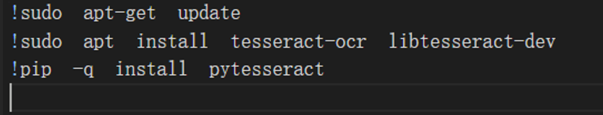

First, use ‘sudo‘ and ’pip‘ statements to install the required algorithms and libraries for subsequent operations. The text recognition model used in this article is tesseract-ocr, and the required library is pytesseract, so you need to run the above statements before running all the codes, otherwise an error will be reported if the colab environment does not have the required module.

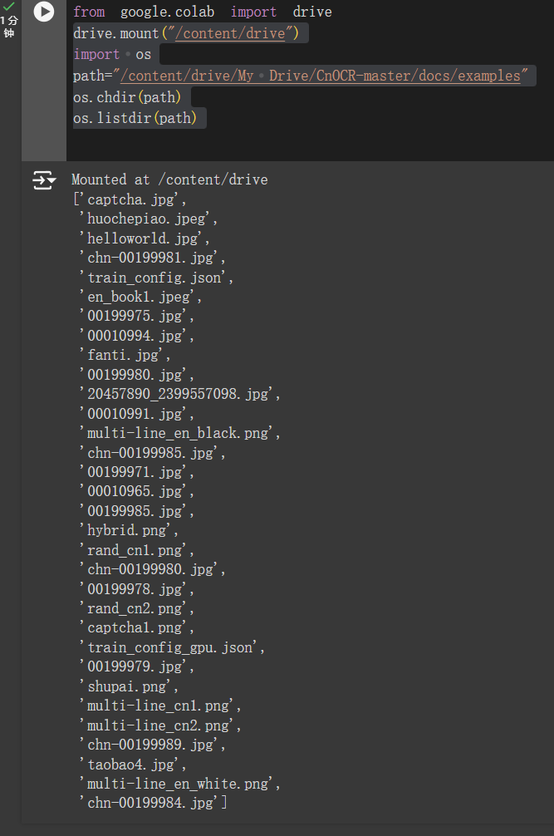

Since Colab is used for demonstration, it is more convenient to directly connect to the image demonstration in Google Drive. Connect Google Drive and click on the permission to connect to the cloud disk in the logged-in account. Then further open the subdirectory in Google Drive for storing the images required for subsequent code to facilitate subsequent operations. As shown in the figure above, the dialog box reflects all the image files in the directory and some other files.

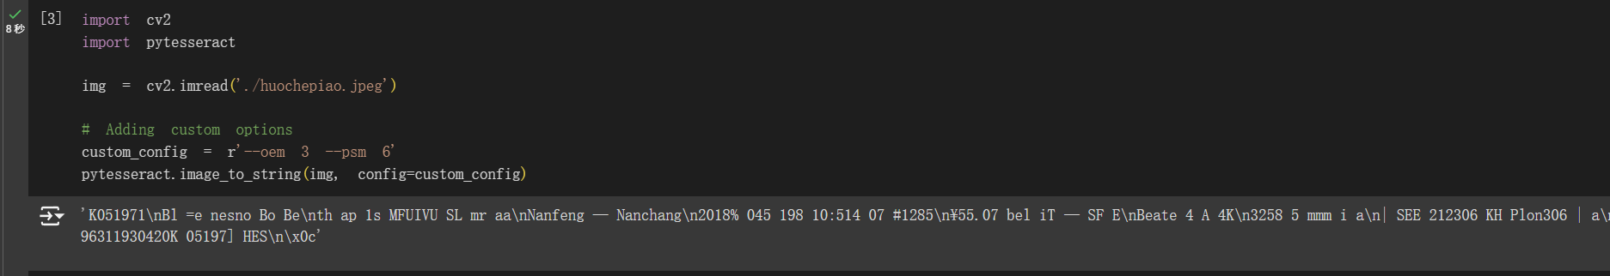

The main purpose of this code is to use OpenCV (cv2) to read image files and use the pytesseract library for optical character recognition (OCR), while optimizing the recognition process through custom configuration options.

First, import OpenCV and pytesseract libraries. The two libraries are used to read and process images and perform optical character recognition, respectively. Use the cv2.imread function to read the image file under the specified path (here is ./huochepiao.jpeg) and store the image in the variable img.

Two places worth noting:

1.oem 3: Specifies the default mode of using the OCR engine, which usually combines neural networks (LSTM) and traditional Tesseract methods to provide better recognition results.

2.psm 6: Set the page segmentation mode to treat the image as a unified text block for recognition, which is suitable for situations where there is only one text area in the image.

Finally, use the image_to_string method of pytesseract to perform OCR operations on the image img, and pass the custom configuration to the method to recognize according to the specified options. Finally, the text string recognized from the image is returned.

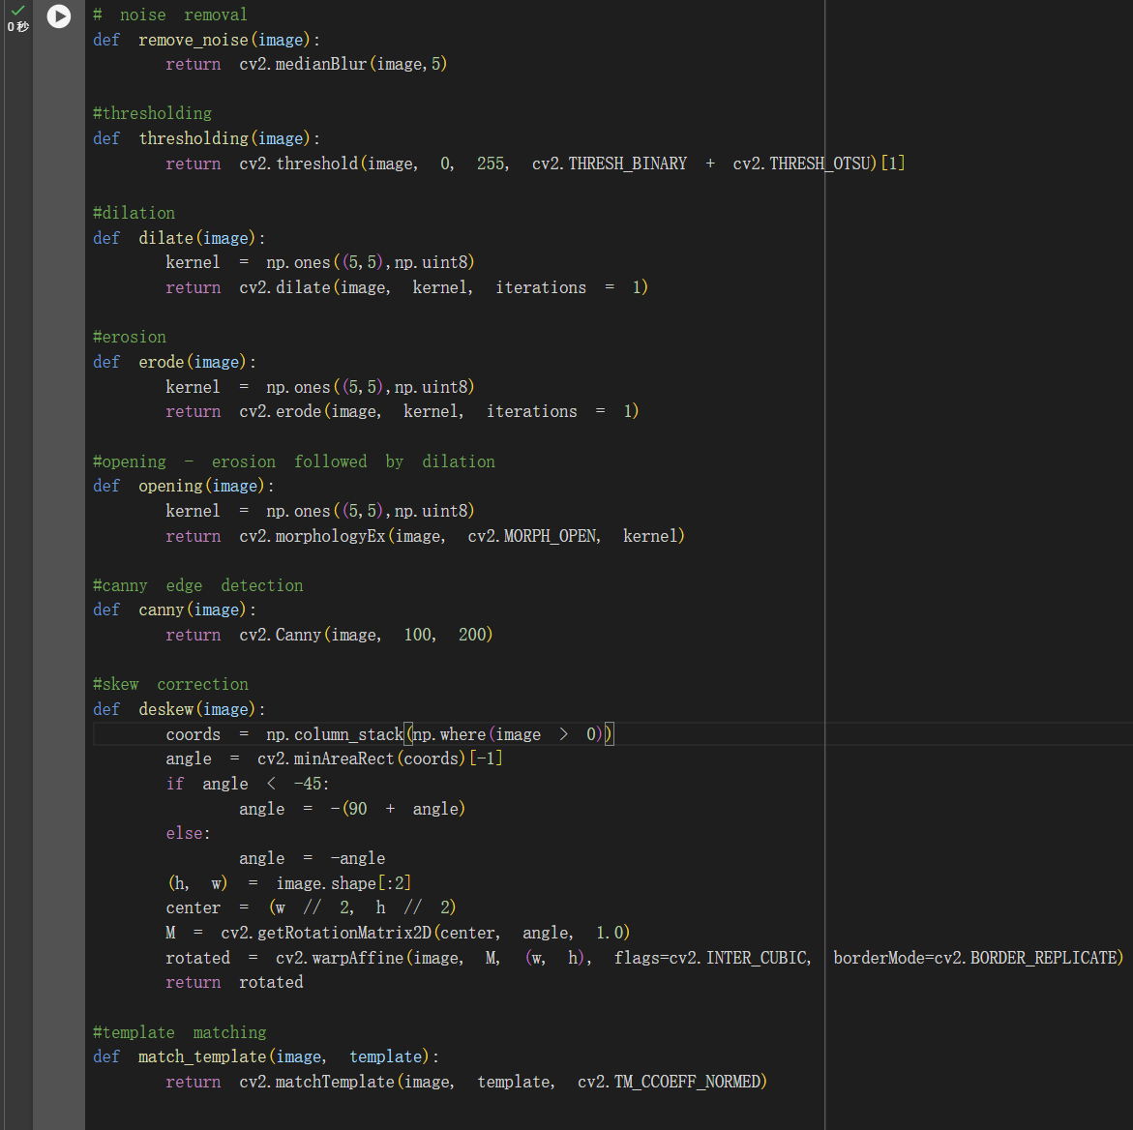

For text detection, it is important to reduce unnecessary interference in the input image. Therefore, reading the image, obtaining its grayscale image, and using cv2.matchTemplate (after searching for the area matching the template template in the input image, calculate the matching degree of each position. Return a two-dimensional array representing the matching score of each position. The higher the score, the higher the matching degree between the position and the template.) can make the subsequent text recognition more accurate.

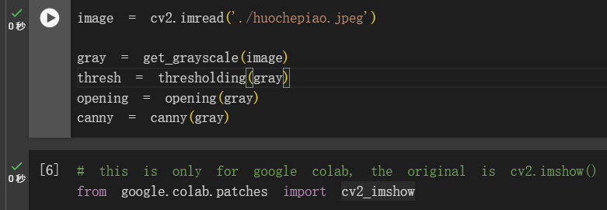

Read the ticket image "huochepiao.jpeg" and further carry out a series of image processing operations, including conversion to grayscale image, threshold processing, morphological opening operation and Canny edge detection. Display the image in the Google Colab environment.

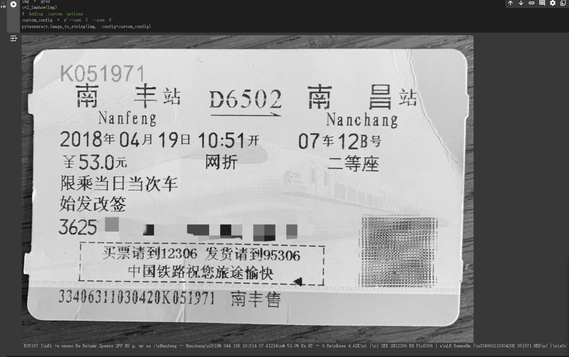

Perform optical character recognition on the ticket image and set some configuration options before recognition. At the same time, the grayscale image is displayed in the Colab environment. Finally, the text content in the image is obtained through pytesseract processing.

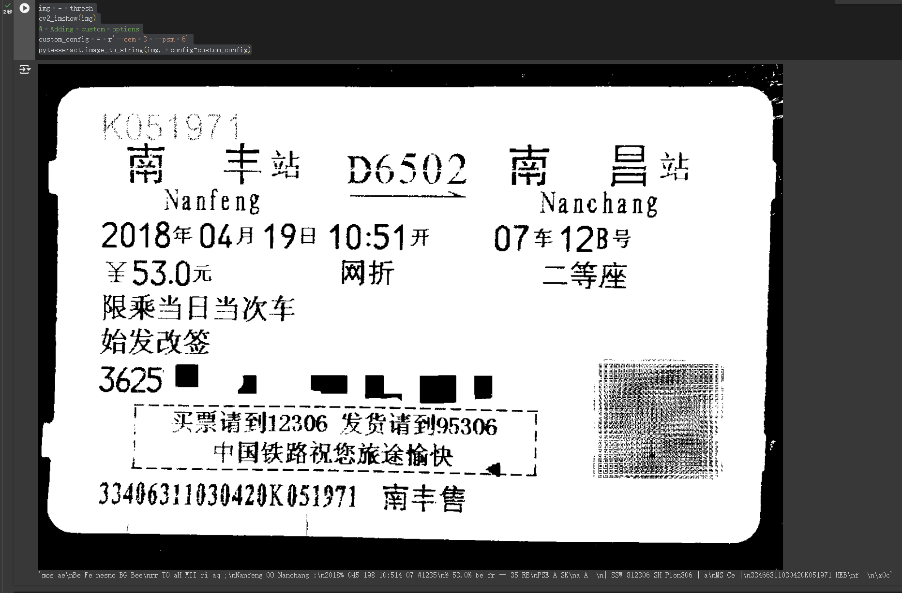

Perform optical character recognition on a thresholded image, use custom configuration to optimize the recognition, and display the image in a Colab environment to review the results.

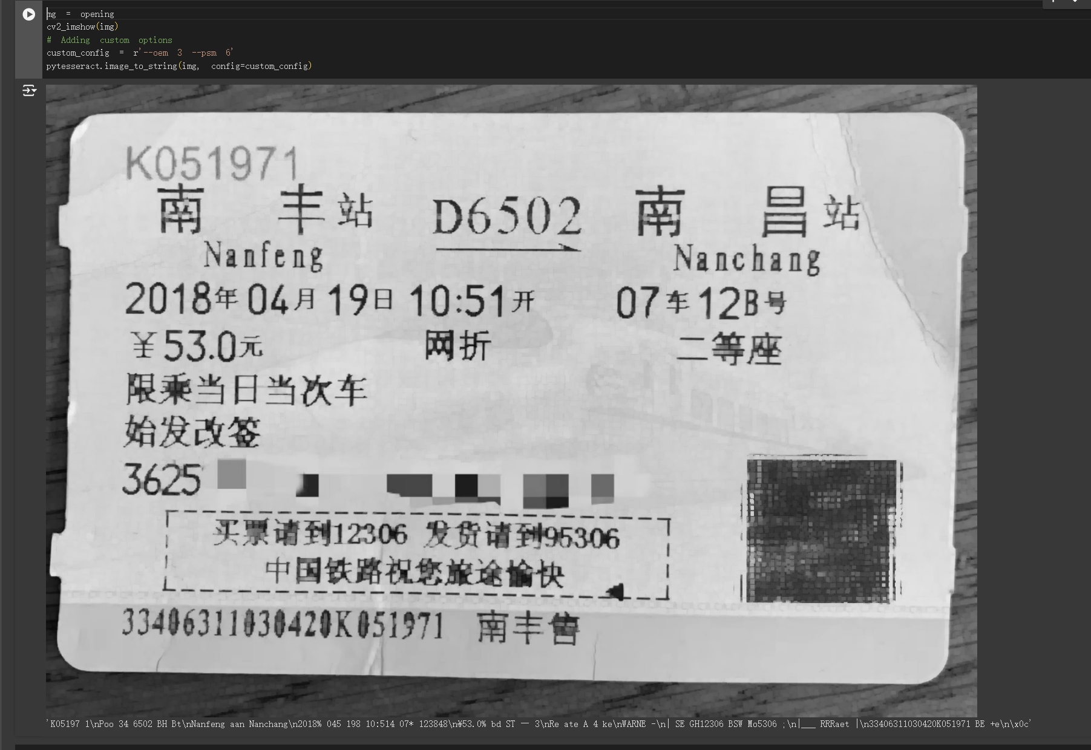

Perform optical character recognition on an image processed by opening operations, optimize the recognition results through custom configuration, and display the image to view the processing results.

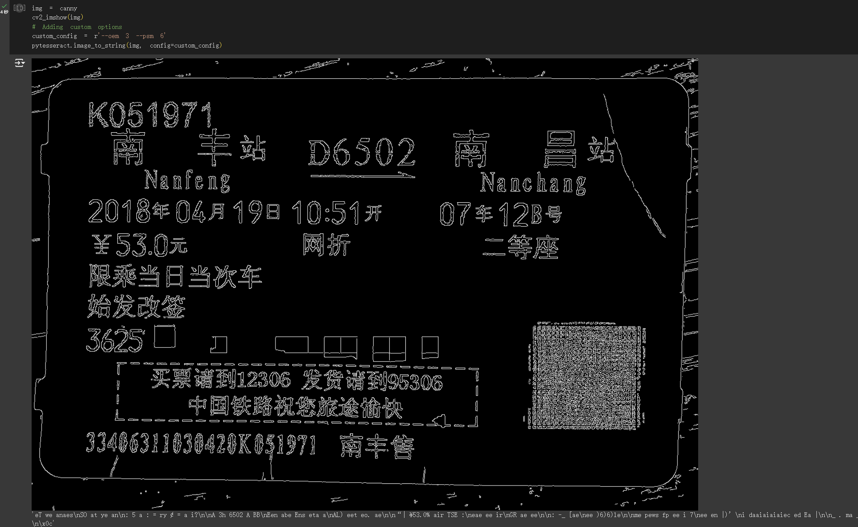

Attempt OCR on a Canny edge detected image and display the image.

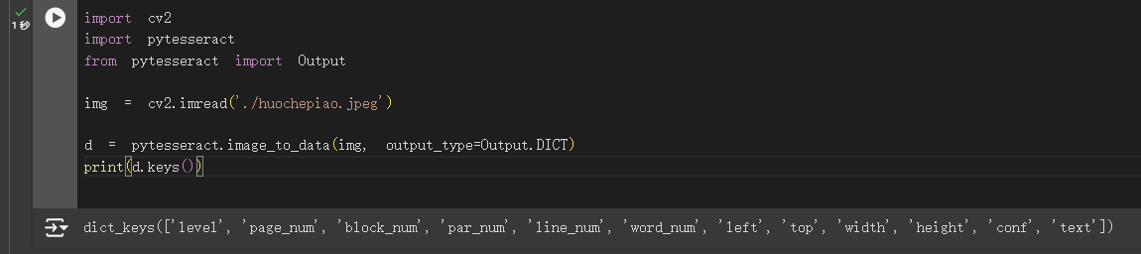

First, we still import the required libraries: cv2, pytesseract, and Output is an enumeration type in pytesseract, which is used to specify the output format as a dictionary. Read the image file and store it in the img variable. Use the image_to_data method of pytesseract to perform OCR processing on the image and store the result in the d variable in the form of a dictionary. This dictionary contains various information about the recognized text, such as the text content, the location of the text in the image, the confidence level, etc. Finally, print out all the keys of the dictionary d to see what information fields are contained in the dictionary.

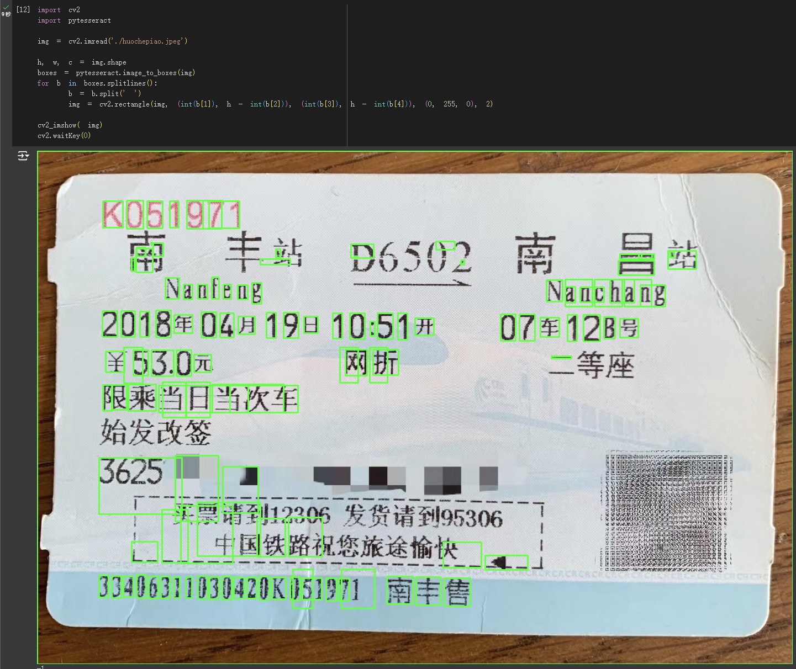

The last step is to read the ticket image, use the pytesseract library for optical character recognition, draw the borders of the recognized characters on the image, and finally display the processed image on the screen. As can be seen from the above figure, the code has the following advantages:

The running time is fast, only 9 seconds; most Arabic numerals and English are correctly recognized, and there are fewer cases of repeated frame extraction and missed frame extraction for such text. However, there are also the following shortcomings: poor recognition ability for Chinese; some places where there is no text are framed.

Since the results of this run are not ideal, I reused the above code and replaced it with a simpler text image. The specific implementation effect can be seen in the figure below: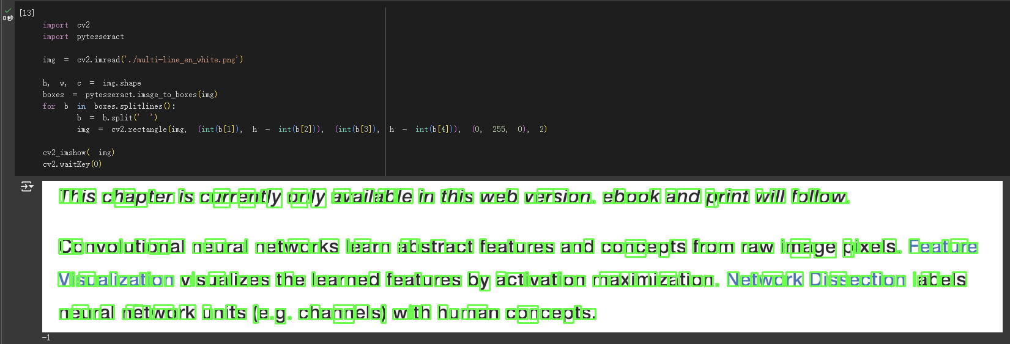

It can be seen that the effect is good. As for the problem of text recognition in ticket images, it is speculated that it may be caused by overfitting, image quality, and too dense text.

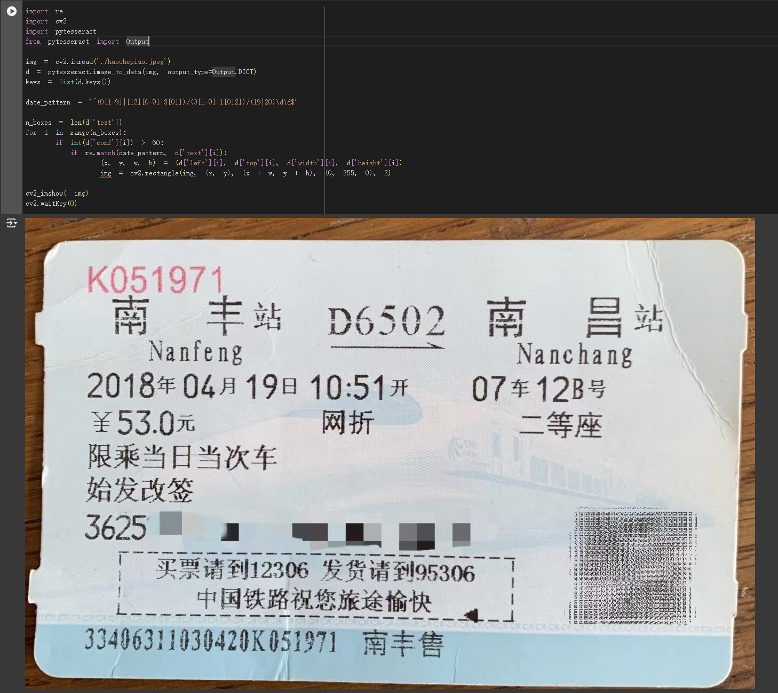

Back to the ticket image, identify the date in the ticket image. For date identification, the format is 'DD/MM/YY', that is, the date in the input image in the form of "day/month/year" is identified, the day range is 1~31, and the month range is 1~12. In particular, the year is limited, only the years 19XX-20XX will be recognized. And use the cv2.rectangle statement to frame it, and the color of the frame is green.

It can be seen that "April 19, 2018" in the output image is not recognized. If you look at the date range defined in the code alone, the date should meet the conditions, but in fact the date is not framed out. This is because the date_pattern statement sets the date format to separate the date units with "/", and needs to be in the order of day, month and year. The date does not meet the format requirements, so it will not be framed out.

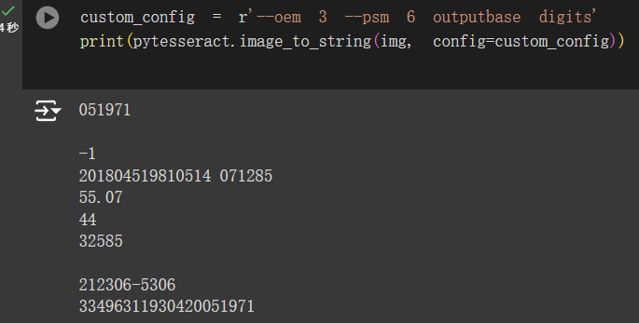

The extraction of numbers from the ticket image runs fast and can recognize most numbers normally, but the recognition result is poor when the numbers are dense or mixed with other types of text. The reasons may still be overfitting of the model, low image quality, too dense text, etc.

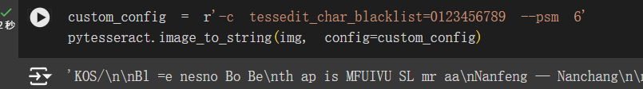

A "blacklist" is set here, and the numbers 0 to 9 will no longer be extracted in subsequent text extraction.

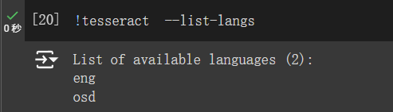

At this moment, only the eng and osd languages ​​can be recognized in the Colab environment.



Use the pytesseract library to extract English text from images and perform optical character recognition based on the specified configuration parameters.

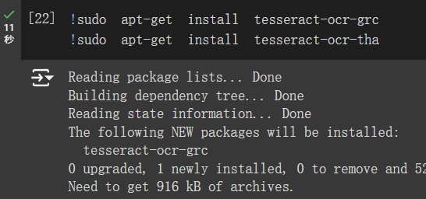

Use the ! sudo statement to install the Ancient Greek and Thai Tesseract OCR language packages respectively to facilitate subsequent text recognition.

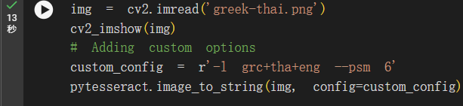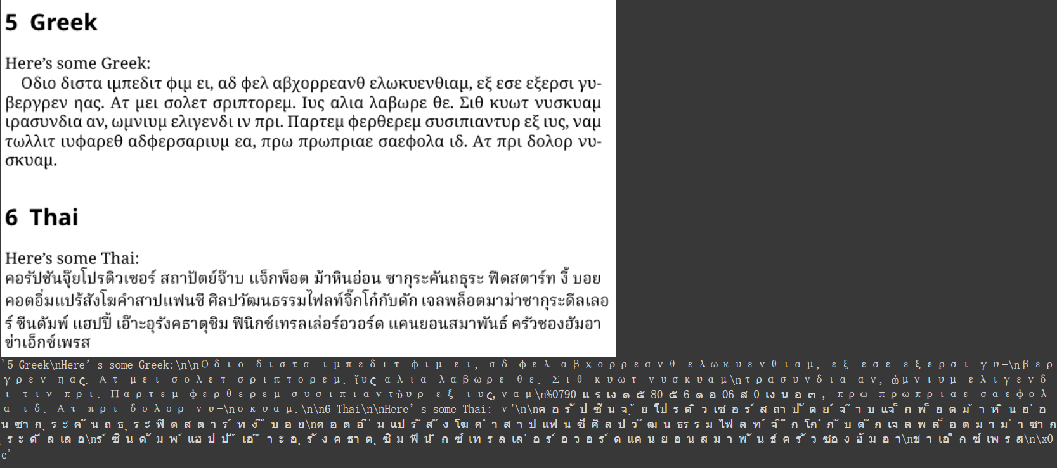

Read the image file 'greek-thai.png', then use Tesseract OCR to recognize the text in the image according to the specified language (Ancient Greek, Thai, English) and page segmentation mode, and obtain the recognition result. The running results are shown in the figure above. It can be seen that the recognition result is still affected by factors such as image quality, text clarity, and the training level of Tesseract OCR.

Next, we download the text recognition algorithm and identify which languages ​​are in the image file 'greek-thai.png'.

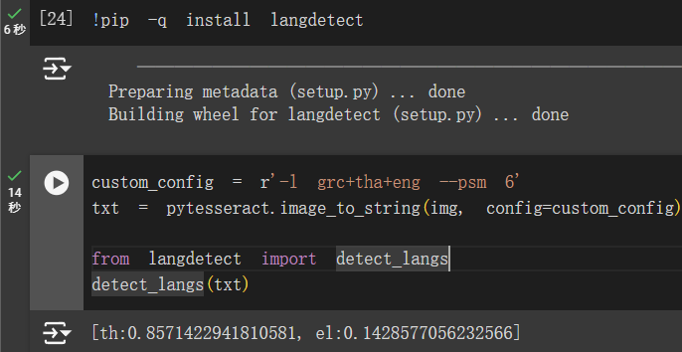

It can be seen that Thai, which has the highest confidence, is placed at the top of the output results. Other words seem to be placed in the el (else) column because they are less or have low confidence, accounting for only 14%. This may be a kind of beauty (metaphysics) that belongs exclusively to code. Obviously, more than half of the pictures are ancient Greek. Maybe the next time you run it again, the most confident words will become ancient Greek again.

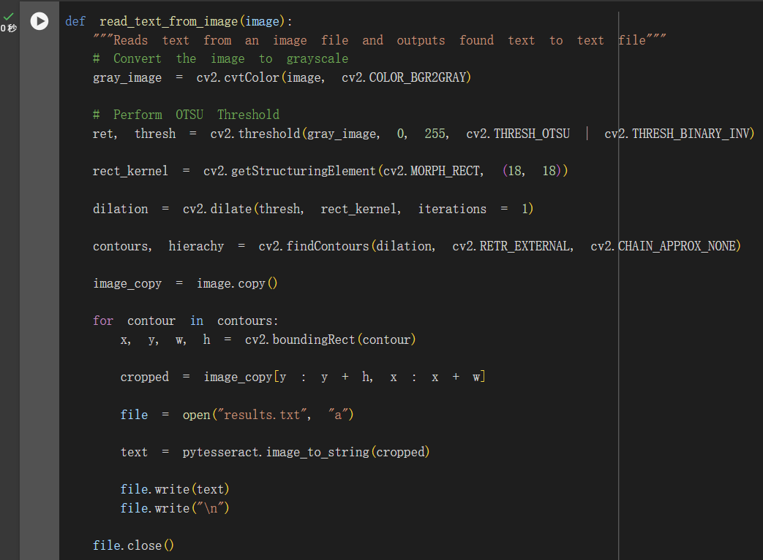

The function read_text_from_image is used to read text from an image and output the recognized text to a text file. It sets some basic properties for text recognition to make text extraction more accurate.

Below I use the lines.reserve statement to write a piece of code to sort the extracted text from bottom to top and print it out in the dialog box: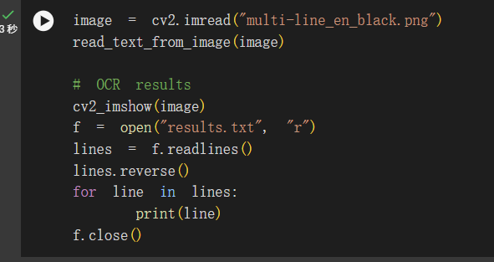

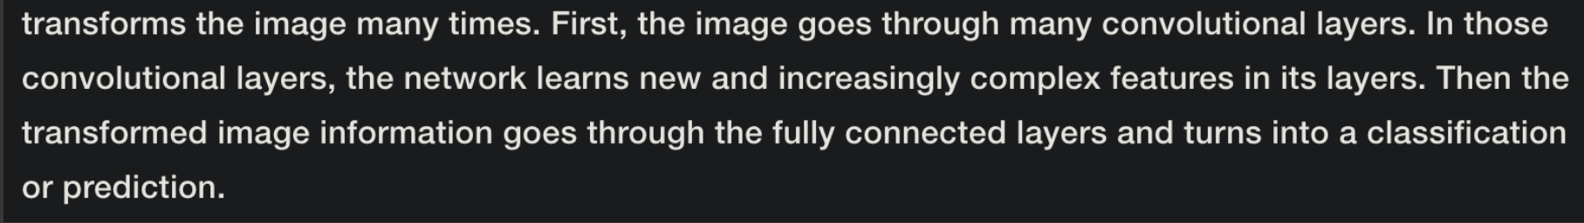

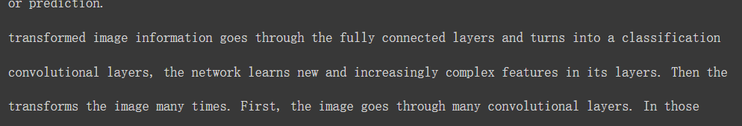

It can be seen that the effect is very good, the recognition speed is fast, the result is very accurate, and the text in the picture is correctly displayed in the dialog box in order from bottom to top.